**ELECTRONIC SALES PROJECT DESCRIPTION, FINDINGS AND RECOMMENDATIONS**

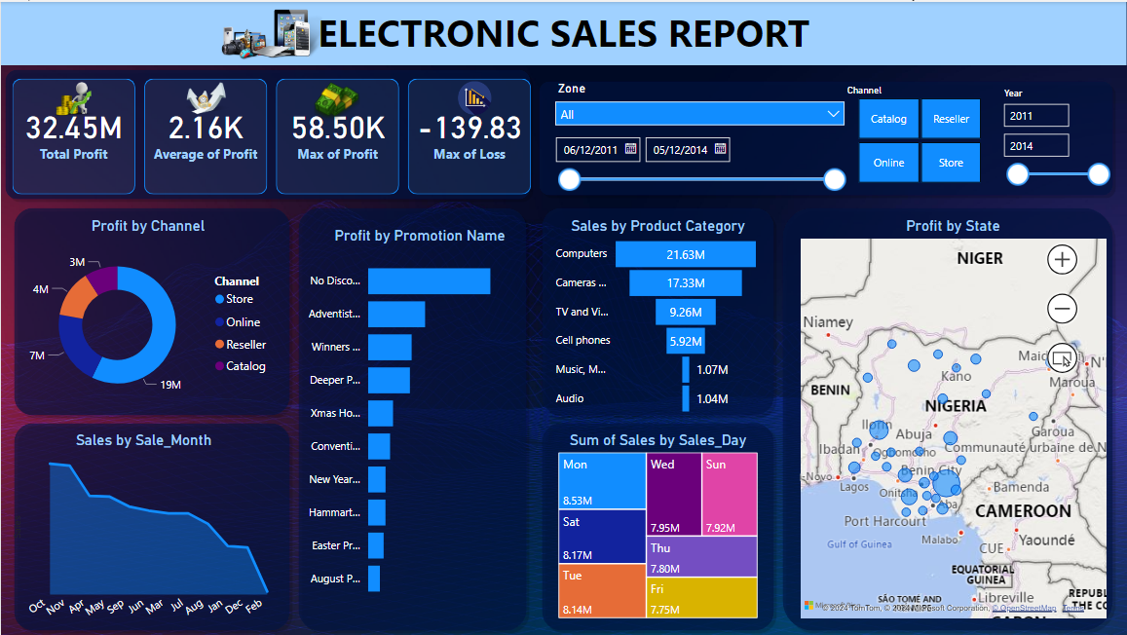

**INSIGHTS & FINDINGS**

From the analysis carried out on the Electronic datasets, the following findings were noted:

* The Total profit made across all states was 32.45M.
* The average profit made was 2.16K.
* The highest profit made was 58.50K
* The most Loss made was 139.83
* Looking through the channels, Stores made the highest profit, followed by Online sales, then Resellers and finally Catalogs
* The highest sale was made in the month of October while the lowest sales was made in the month of February.
* Sales with No Discount made the highest profit.
* Computers made so much sales than the others.
* The highest profit was made in Ebonyi state than other states.

**RECOMMENDATIONS:**

From the insights generated from the analysis, the following recommendations can be considered.

* More products should be allocated to Ebonyi state.
* More stores than other channels should be created to facilitate sales and generate more profit.
* No discount method should be more considered.
* The company should increase purchase of Computers than other items.